**ASN Creation:**

1. KGB inbound admin will select Country of Origin (COO).
2. System will default the COO column in the PO Details.
3. If KGB inbound admin identified that one or more lines have different COO then he will need to manually amend the COO for each line with different COO other than specified in the header level.

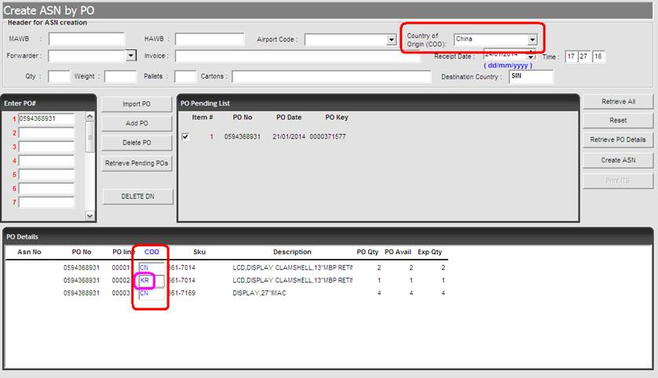

**ITS & RF**

1. The COO column in the ITS will be retrieved based on the value of COO in the PO Details upon ASN creation.
2. The COO field in the RF screen will be removed to prevent Ops from overwriting.  Ops will submit a Change Request to Manish approval and subsequently send to RHO IT for development.